Before Bridge Design Pattern

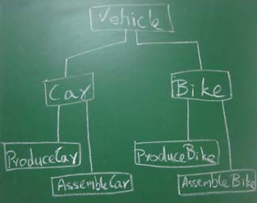

After Bridge Design Pattern
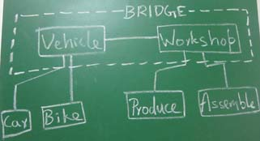

package mypack;

/**
* abstraction in bridge pattern
* */
abstract class Vehicle {
protected Workshop workShop1;
protected Workshop workShop2;

protected Vehicle(Workshop workShop1, Workshop workShop2) {
this.workShop1 = workShop1;
this.workShop2 = workShop2;
}

abstract public void manufacture();
}

package mypack;

/**
* Refine abstraction 1 in bridge pattern
*/
public class Car extends Vehicle {

public Car(Workshop workShop1, Workshop workShop2) {
super(workShop1, workShop2);
}

@Override
public void manufacture() {
System.out.print("Car ");
workShop1.work();
workShop2.work();

}

}

package mypack;

/**
* Refine abstraction 2 in bridge pattern
*/
public class Bike extends Vehicle {

public Bike(Workshop workShop1, Workshop workShop2) {
super(workShop1, workShop2);
}

@Override
public void manufacture() {
System.out.print("Bike ");
workShop1.work();
workShop2.work();
}

}

package mypack;

/**
* Implementor for bridge pattern
* */
public interface Workshop {
abstract public void work();
}

package mypack;

/**
* Concrete implementation 1 for bridge pattern
* */
public class Produce implements Workshop {

@Override
public void work() {
System.out.print("Produced");
}

}

package mypack;

/**
* Concrete implementation 2 for bridge pattern
* */
public class Assemble implements Workshop {

@Override
public void work() {
System.out.println(" Assembled.");
}

}

package mypack;

/*
* Demonstration of bridge design pattern
*/
public class BridgePattern {

public static void main(String[] args) {

Vehicle vehicle1 = new Car(new Produce(), new Assemble());
vehicle1.manufacture();
Vehicle vehicle2 = new Bike(new Produce(), new Assemble());
vehicle2.manufacture();

}
}

Output:
Car Produced Assembled.
Bike Produced Assembled.

